|  |  |  |  |  |
| --- | --- | --- | --- | --- |
| Classification and Simulation of Diverse Modulation techniques using SDR tools   |  |  | | --- | --- | | V. Sidharrth  *Department of Artificial Intelligence,*  *Amrita School of Artificial Intelligence, Bengaluru*  *Amrita Vishwa Vidyapeetham,* [bl.en.u4aid23054@bl.students.amrita.edu](mailto:bl.en.u4aid23054@bl.students.amrita.edu) | B G Rajath Siddarth  *Department of Artificial Intelligence,*  *Amrita School of Artificial Intelligence, Bengaluru*  *Amrita Vishwa Vidyapeetham, India*  [bl.en.u4aid23006@bl.students.amrita.edu](mailto:bl.en.u4aid23006@bl.students.amrita.edu) | | Palle Venkata Dharaneswara Reddy  *Department of Artificial Intelligence,*  *Amrita School of Artificial Intelligence, Bengaluru*  *Amrita Vishwa Vidyapeetham, India*  [bl.en.u4aid23065@bl.students.amrita.edu](mailto:bl.en.u4aid23065@bl.students.amrita.edu) | Ms. Sirisha Tadepalli  *Department of Artificial Intelligence,*  *Amrita School of Artificial Intelligence, Bengaluru*  *Amrita Vishwa Vidyapeetham, India*  t_sirisha@blr.amrita.edu | |

*Abstract*— This report delves into the implementation and analysis of communication systems using MATLAB, focusing on key modulation techniques. The study emphasizes Frequency Shift Keying (FSK), Frequency Modulation (FM) approach for signal processing. MATLAB's robust simulation environment enabled the visualization and evaluation of these methods, providing insights into their practical applications in modern communication systems. FSK, a widely used digital modulation scheme, was explored for its simplicity and reliability in transmitting binary data. Simulations demonstrated the technique's effectiveness in ensuring data integrity across varying channel conditions. FM, known for its resistance to noise, was analyzed for analog communication, highlighting its advantages in transmitting high-quality audio signals. Additionally, the report discusses the role of the LSB technique in digital steganography, showcasing its utility in embedding and extracting data within audio signals without compromising the carrier's quality. The results validate the efficiency of these methods, with MATLAB simulations highlighting the strengths and limitations of each. The highest accuracy in classification of modulation techniques is 77%, given by the K nearest neighbours algorithm. The findings underscore the importance of selecting appropriate modulation techniques based on application requirements. By leveraging MATLAB's capabilities, this study bridges theoretical knowledge with practical insights, equipping researchers with tools to advance communication system design. The report concludes with recommendations for optimizing modulation schemes to enhance data transmission reliability and efficiency in real-world scenarios.

Keywords— Frequency Shift Keying, RTL SDR, MATLAB, GNU Radio, Random Forest, KNN, XGBoost, Decision Tree

# Introduction

Living in the era of communication where everything may be video, audio or any information in the form of electrical signal is termed as data and there is an enormous requirement of data transfer between two or more point through the world wide web, every moment of the clock, which is a big threaten to the existing communication systems because of the problems like spectral congestion, severe adjacent & co-channel interference problems and noise corrupted data reception etc. This has resulted in serious need for the research work all around the world for the development of the communication systems which can handle the above said problems, where each aspect of the communication systems is dealt with the development of new encoding techniques, modulation techniques, possibilities for newer transmission channels and off course the demodulation and decoding techniques [1, 2]

Modulation is the process of varying some parameter of a periodic waveform in order to use that signal to convey a message. Normally a high-frequency sinusoidal waveform is used as carrier signal. For this purpose ,if the variation in the parameter of the carrier is continuous in accordance to the input analog signal the modulation technique is termed as analog modulation scheme if the variation is discrete then it is termed as Digital Modulation Technique[3].

There are basically three type of analog modulation schemes the amplitude modulation, the Frequency modulation and the phase modulation schemes which have in turn lot of class, subclass or derivatives [4,5]. In case of the Amplitude Modulation there are several derivatives and among thode Single Side Band Suppressed Carrier (SSS-SC) has smaller bandwidth and power requirements in contrast with Double Side Band Suppressed Carrier (DSB SC) and Double Side Band Full Carrier (DSB FC) but for detection of this signal, we require sharp cutoff Low Pass Filter (LPF) which is not practically viable.

The Amplitude modulated signals require nonlinear amplifiers which generate spurious out-of-band spectral components which are filtered out with a great difficulty. Frequency Modulation proves to be better in comparison to amplitude modulation and phase modulation, and the derivative of frequency modulation, narrow band FM (NBFM) is usually employed to overcome above mentioned problems in the communication system [6,7] . The great merit of FM over AM is that FM allows us to suppress the effects of noise at the expense of bandwidth. The major limitation of the analog modulation systems for communicating over long channels is that once noise has been introduced at any place along the channel, then it is carried out till the end.

Considering the advantages and the potential benefits of Frequency modulation techniques over Amplitude modulation techniques and the better spectral efficiency of Lower Side band amplitude modulation, it has been deemed essential to classify these modulation techniques. Classifying modulation techniques is essential to understand their characteristics and choose the most suitable one for specific applications. It helps evaluate performance in terms of bandwidth efficiency, power efficiency, and error tolerance under varying conditions. By organizing them into categories, such as analog or digital modulation, engineers can simplify system design, optimize resource utilization, and ensure compatibility with hardware and standards. This classification also supports adaptive communication systems, like 5G, which switch between modulation schemes based on channel conditions, making communication more efficient and reliable.

Adding to this, the rapid expansion of communication needs across diverse domains—such as data, voice, video, emergency response, and broadcast messaging—has driven the demand for cost-effective and easily modifiable radio technologies. Software Defined Radio (SDR) addresses this demand by offering flexibility, cost efficiency, and adaptability. Unlike traditional hardware-dependent radios, SDR employs a software-driven approach to implement some or all physical layer functions, allowing multimode, multiband, and multifunctional capabilities. By leveraging programmable technologies, SDR eliminates the need for frequent hardware upgrades. This enables seamless integration of new features and capabilities through software updates, fostering innovation while significantly reducing production and maintenance costs.

The benefits of SDR span various stakeholders. For equipment manufacturers and system integrators, SDR facilitates the development of versatile product families using a common platform, reducing time-to-market and enabling software reuse to lower development expenses. Service providers benefit from SDR's ability to add features to existing infrastructures without heavy capital investments, supporting scalability and network evolution. End users, ranging from business professionals to soldiers, experience cost savings and enhanced communication reliability. By enabling over-the-air updates, bug fixes, and feature enhancements, SDR empowers users to connect seamlessly and efficiently, making it an essential driver of modern communication systems.

GNU Radio and RTL-SDR are powerful tools that have revolutionized the accessibility and functionality of Software Defined Radio (SDR). GNU Radio is an open-source framework that provides a flexible platform for developing and simulating SDR systems. It enables users to design and implement radio systems by building software flowgraphs, combining signal processing blocks for a wide variety of applications, including communication systems, signal analysis, and radio astronomy. Complementing GNU Radio, RTL-SDR is a low-cost SDR hardware platform derived from repurposed TV tuner dongles. Its affordability and wide frequency range make it a popular choice for hobbyists and professionals alike to explore SDR applications. Together, GNU Radio and RTL-SDR democratize SDR technology, allowing users to experiment, learn, and innovate in wireless communication without the need for expensive, proprietary equipment.

MATLAB has a powerful Simulink dynamic simulation environment that provides a graphical interface for modeling with block diagrams [8].

Therefore, in our work, we propose to do a hardware project, where we simulate communication in a frequency shift keyed system, with the aid of MATLAB. Furthermore, the crucial need for classification of modulation techniques have piqued our curiosity. Hence, we shall draw the flowgraphs of the three modulation techniques, i.e., Narrow Band Frequency Modulation(NBFM), Wideband Frequency Modulation(WBFM) and Lower Side Band(LSB) and with the help of RTL SDR source, we generate CSV files to run machine learning models on them.

The organization of the rest of the paper has been done as follows. Section II is about the principle of frequency shift keying. The details of the proposed model are elucidated in Section III. Section IV presents the experimental results. Lastly, the paper has been concluded in Section V.

# Principle Of Frequency Shift Keying

It is a technique that is used to transmit digital information in the form of zeros and ones by switching a carrier between discrete frequencies. We can contrast this with analog frequency modulation, where the carrier is continuously varied based on an analog input signal.

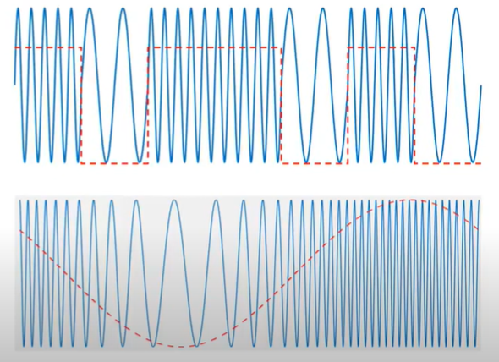

Figure 1 The comparison between FSK and FM

The number of discrete frequencies can be:

* Two- binary FSK
* More than two: M-ary FSK

Binary FSK (or BFSK) uses two frequencies:

* Mark: corresponds to logical 1
* Space: corresponds to logical 0

The mark is always the higher of the two frequencies. The distance between carriers and nominal center frequency (fc) is called the frequency deviation or shift and hence the name frequency shift keying.

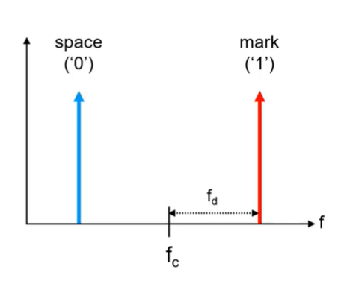

Figure 2 BFSK

In BFSK, the bit rate equals the baud rate. Each symbol (mark or the space) is of one bit. In other words, in each symbol interval we can transmit either a zero or a one, that is 1 bit.

Looking at the time domain representation of FSK, it can be clearly seen that the amplitude of carrier does not change. This is a significant advantage because it simplifies amplifier design and selection. We can still recover the information even if a non linear amplifier causes amplitude fluctuations in the transmitted or received signal.

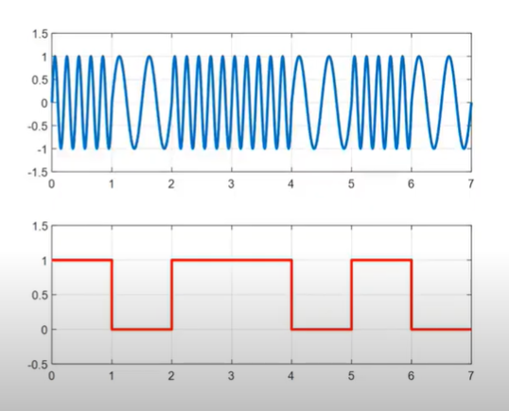

Figure 3 Time domain representation of FSK

Coherent and non-coherent FSK can be distinguished. If two BFSK tones are generated by the same oscillator, then it is coherent or continuous FSK. If they are generated by separate oscillator, the result is non coherent FSK. In the case of a non coherent FSK, the lack of a common oscillator can produce phase discontinuities at switching points. This can lead to wider signal bandwidth or bit errors. But they are cheaper to implement.

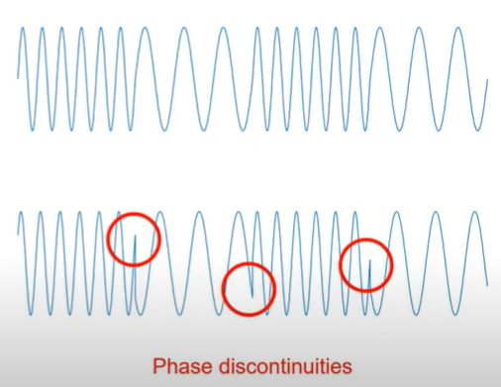

Figure Lower Sideband Modulation

Figure 4 Coherent and non coherent FSK

The variants of coherent FSK are Minimum Shift Keying (MSK) and Gaussian Minimum Shift Keying (GMSK). These allow closer spacing of two tones. Some applications of FSK are paging systems, telemetry and data collection.

# Proposed Methodology

## The hardware project

Two types of modulation- Lower Side Band Modulation, and Wideband Frequency have been simulated in this work. With the help of GNU Radio as a platform, and RTL SDR interface, the block diagram of each of these modulation techniques have been depicted in the flowgraph and signals have been recorded and captured in the Audio sink, where we can hear the wideband frequency modulated signal. The narrowband frequency modulated signal wasn’t however distinctly audible.

The workflow of the research has been detailed below:

1. Lower Sideband Modulation:

The RTL-SDR Source block initializes signal capture, setting a sample rate of 2.4 MSps, a center frequency of 132.15 MHz, and other gain parameters for optimal reception. The signal is filtered through a Low Pass Filter, which reduces noise by limiting the bandwidth to 2.7 kHz. Afterward, the Rational Resampler adjusts the sample rate by interpolating by 12 and decimating by 5 to match downstream processing requirements. The signal then passes through a Hilbert Transform, creating the analytic signal required for processing single-sideband (SSB) modulation. Following this, the Complex to Float blocks separate the real and imaginary components, which are processed and combined to extract the desired information. Null sinks are used to discard unnecessary data streams during the subtraction operation.

The processed signal is further amplified using the Multiply Const block and converted back to complex form using a Float to Complex block. This final processed signal is sent to both an Audio Sink, converting it into audio at a 48 kHz sample rate, and a File Sink, which writes the data to a CSV file for storage or analysis. Visual feedback is provided by the QT GUI Sink, which displays the signal spectrum or other relevant plots. Adjustable parameters like RF gain, volume, and frequency are controlled dynamically using QT GUI Range widgets. A diagram of a computer code

1. Frequency modulation

This block diagram outlines a wideband FM (WBFM) signal processing pipeline implemented using GNU Radio, with the RTL-SDR Source Block as the input. The signal acquisition begins with the RTL-SDR hardware, configured to receive an FM broadcast at 91.1 MHz with a sample rate of 2M samples/second. The source block allows control over gain parameters (RF, IF, BB gains) and applies no frequency correction or DC offset adjustments. The incoming signal undergoes an initial resampling step via the Rational Resampler (Interpolation = 1, Decimation = 1) as a placeholder to ensure compatibility with subsequent processing stages. A Low Pass Filter is then applied to remove high-frequency noise and isolate the FM signal within a 100 kHz cutoff frequency.

The filtered signal is further resampled using another Rational Resampler to align it with the quadrature rate of the WBFM Receive Block, which performs FM demodulation. The demodulated audio signal, decimated by a factor of 10 to a 48 kHz audio rate, is optionally scaled using the Multiply Const Block and can be converted back to complex form using the Float to Complex Block. The output is directed to the Audio Sink for playback and simultaneously saved to a file via the File Sink for offline analysis. Additionally, a QT GUI Sink provides a visual representation of the signal spectrum, allowing real-time monitoring with a bandwidth of 2M and FFT size of 1024. This setup effectively processes FM signals for playback, storage, and visualization. 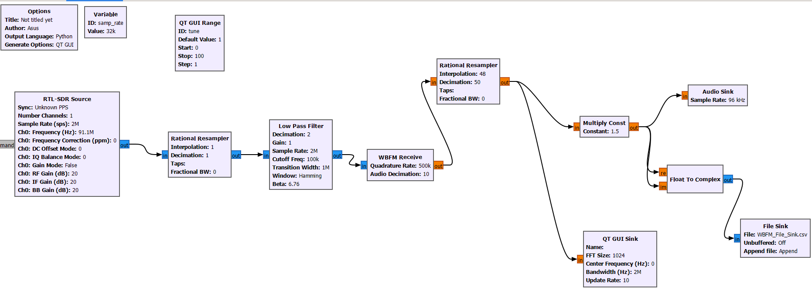

Model development:

The following are the machine learning models that have been trained in this for work for classification of the modulation techniques:

1. Random Forest (RF):

Random Forest is an ensemble learning method that builds multiple decision trees during training and combines their outputs to improve accuracy and robustness. It leverages feature randomness and bootstrapping to create diverse trees, reducing overfitting and enhancing generalization. In modulation classification, RF is particularly advantageous because it captures non-linear relationships between real and imaginary components while remaining robust to noise. Additionally, RF provides insights into feature importance, helping to identify which aspects of the signal are most significant for distinguishing between modulation techniques.

2.Decision Tree (DT):

Decision Tree is a simple yet effective model that splits data based on feature thresholds, forming a tree-like structure that is easy to interpret and visualize. In the context of modulation classification, DT’s simplicity makes it a great starting point for understanding how signal components contribute to the classification task. Its low computational cost and fast decision-making process are ideal for scenarios requiring real-time performance. However, its susceptibility to overfitting makes it less robust than ensemble methods, which is why it is often used in conjunction with other models.

3.K-Nearest Neighbors (KNN):

K-Nearest Neighbors classifies data based on the majority label among the nearest neighbors in the feature space. This model is particularly effective in modulation classification due to its geometric intuition, directly using the distances between real and imaginary components to make predictions. KNN is non-parametric, meaning it does not assume any specific data distribution, making it flexible for different modulation techniques. Its simplicity and effectiveness in small, well-separated datasets make it a valuable model for understanding the underlying patterns in the data.

4.XGBoost:

XGBoost is a gradient-boosting-based ensemble method known for its high accuracy and scalability. It sequentially builds decision trees that optimize errors from previous iterations, capturing complex feature interactions in the process. For modulation classification, XGBoost excels in handling high-dimensional data and provides regularization techniques to prevent overfitting, making it robust for noisy and small datasets. Its efficiency and ability to leverage both real and imaginary components effectively make it a top choice for achieving state-of-the-art results in signal classification tasks.

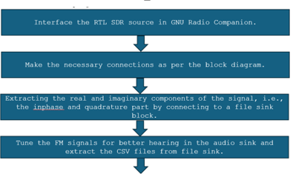

Figure Frequency modulation

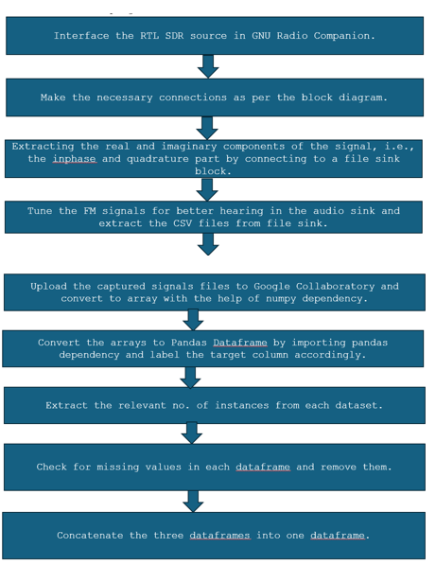

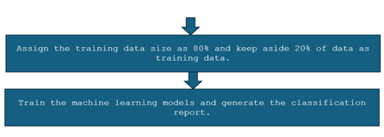

Figure 7 Workflow

## The simulation project

This block diagram represents the implementation of Frequency Shift Keying (FSK) modulation in a simulation setup. FSK is a modulation scheme where digital information is transmitted through discrete frequency changes of a carrier wave. In this diagram, the Bernoulli Binary Generator creates a random binary signal consisting of 0s and 1s, which serves as the input data for modulation. This binary signal is fed into a Switch block, which determines the selection of one of two sine wave signals based on the binary input value. When the binary input is '1', the switch routes a high-frequency sine wave (denoted as "Sine Wave 1") as the output, and when it is '0', it routes a lower-frequency sine wave (denoted as "Sine Wave"). This process implements FSK, as the output frequency depends on the binary input signal.

In the demodulation phase, the modulated signal undergoes coherent demodulation, where in we pass the derivative of the signal, take the square of it with the help of product block and use a low pass filter to take the low frequency components. The same can be achieved by a band pass filter or PLL too.

Figure 8 FSK Modulation and Demodulation

# Results And Analysis

The highest obtained accuracy in the classification of the modulation techniques was 77% with KNN model. The compromise in accuracy is due to the fact that the real and imaginary components of signal do not give a proper validation of the pattern in the features of the signal. The accuracy of the models have been tabulated below:

|  |  |
| --- | --- |
| Model | Accuracy |
| KNN | 77 |
| Decision Tree | 73 |
| XGBoost | 72 |
| Random Forest | 73 |

The simulation results obtained illustrate both the modulation and demodulation stages of Frequency Shift Keying (FSK). The first waveform represents the binary data generated by the Bernoulli Binary Generator, which alternates between logical '0' and '1'. This signal serves as the input to the modulation process, dictating the frequency selection for the carrier wave. The second and third waveforms correspond to the two sine wave carriers: the second being the low-frequency carrier representing '0' and the third being the high-frequency carrier representing '1'. The switching between these carriers is controlled by the binary input, demonstrating successful implementation of the FSK modulation process.

The fourth waveform represents the FSK-modulated signal, where the carrier frequency alternates between the two discrete values based on the binary input. The clear transitions between the two frequencies confirm that the modulation is functioning correctly, with no apparent distortions or inconsistencies. The frequency of the output matches the binary data pattern, validating the integrity of the signal generation. This modulated signal is then passed through a demodulation stage to retrieve the original binary data.

The last waveform shows the demodulated signal obtained after processing the FSK-modulated signal. This waveform matches the original binary input, confirming that the demodulation process has accurately extracted the transmitted data. The absence of significant noise or errors in the recovered binary signal highlights the efficiency and reliability of the system design. These results affirm the successful implementation

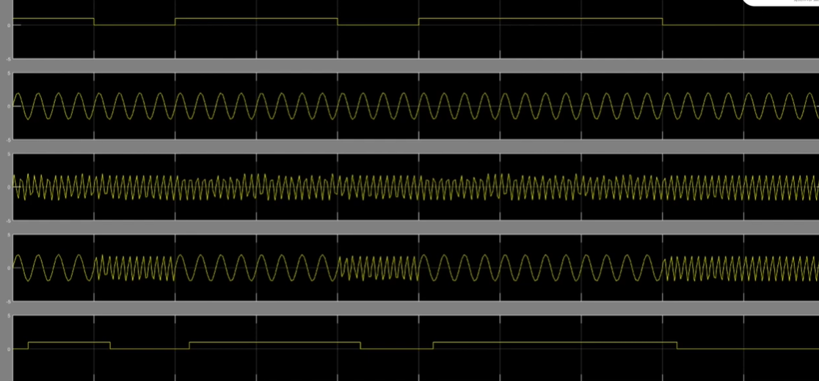

Figure 9 FSK Modulation and demodulation

##### References

1. S. Haykin, Digital Communication, John Wiley & Sons, Inc., Replika Press Pvt. Ltd., N. Delhi, India, 2000-2001.
2. A.B. Carlson, P.B. Crilly, J.C. Rutledge, Communication Systems, McGraw-Hill, Singapore, International Edition, 2002, (4th Ed)
3. A. N. Rydbeck and C. E. Sundberg, "Continuous Phase Modulation – Part II: Full Response Signaling," IEEE Transactions on Communications (Legacy, pre-1988), vol. COM-29, no. 3, pp. 210–225, 1981.
4. J. Salz, "Communications Efficiency of Certain Digital Modulation Systems," IEEE Transactions on Communication Technology, vol. COM-18, no. 2, pp. 97–102, 1970.
5. N. D. Andrea, U. Mengali, and M. Morelli, "Symbol Timing Estimation with CPM Modulation," IEEE Transactions on Communications, vol. 44, no. 10, pp. 1362–1372, 1996.
6. M. Campanella and G. Mamola, "On the channel capacity for constant envelope signals with effective bandwidth constraint," IEEE Transactions on Communications, vol. 38, no. 8, pp. 1164–1172, 1990.
7. M. Campanella, G. Mamola, and E. Randazzo, "Effective bandwidth optimization for non-coherent full response CPM systems," IEEE Transactions on Communications, vol. 41, no. 11, pp. 1606–1609, 1993.
8. M. Y. Xu and Y. B. Shao, Simulation Application of MATLAB in Communication and Electronic Engineering. Xidian University Press, 2005.